Perspective on Why are suicide cases on the rise in this pandemic?



SOC101 Research Paper

Perspective on Why are suicide cases on the rise in this pandemic?

Course: SOC101

Section: 22

Researcher-

Ishtiaque Hossain Sajid, ID: 1731485030

Nafis Kamal, ID: 2011534630

Ashik uz zaman, ID: 2013841630

Tanha Tasnim Azad, ID: 2011367630

Jannatul Ferdous Efat, ID: 2012431630

Supervisor-

Azmat Ara Ahmad (AAA) Ma’am,

Department of Political Science and Sociology,

North South University

Date: 12/01/2021

Table of Contents

Abstract 3

Introduction 4

Hypothesis and Importance 4

Literature Review 4

Methods: 8

Limitations 8

Data Presentation 9

Interview Results 9

Survey Results 11

Conclusion 16

References 17

Appendix 18

Interviews 20

# Abstract

Understanding the depth of increase in suicidal rates in the past one year, also with that the state of depression among the young to young adults, we have decided on to find the reasonings behind such issues. With that in mind, first we did some secondary research, reviewed the existing literature. Some interesting facts came up, including how the increase in suicides is a reality. However, as we found some gaps in understanding the emotions and core problems, we took on primary research. At first, we progressed with three hypotheses. After conducting detailed interviews and close ended surveys, two of our hypotheses proved to be true, that is we found the economic problem to be the main reason people think that others become suicidal. We also found that rather than other issues like death of closed one, the loneliness and changed environment further motivates one towards suicide. At last, we also rounded up some possible remediations with the help of respondents on how to get past the problem in discussion.

# Introduction

## Hypothesis and Importance

Mental health is no joke, it is high time the people of our country understand the importance of mental health. Suicides have increased by a lot around the world. Specially in Japan, the suicide rate is all time high. In Bangladesh too, there are multiple reports of suicides, and depression among the urban population is very high. So, our research is to find out the reasons behind such suicides and try to find out specific reasons behind such trend. The literature available already have not actually taken Bangladeshi people, teen or students into context while the local researches have not taken a look into reasons in the recent times.

For our research, we have devised 3 hypotheses.

1. Economic or Financial Problem are the main reason behind suicidal tendency.
2. Not Finding solution to the new normal increases the tendency.
3. People are able to acknowledge suicidal tendency as an issue now.

## Literature Review

This paper talks about the recent increase in suicide cases during the Covid-19 pandemic.

Suicide is the act of killing yourself, most often due to depression or other mental illness. (American Psychological Association, n.d.) Suicide often stems from a deep feeling of hopelessness. The inability to see solutions to problems or cope with challenging life circumstances may lead people to see taking their own lives as the only solution to a temporary situation. Most survivors of suicide attempts go on to live full, rewarding lives. (Psychology Today, n.d.)

The incidence and mortality of Covid-19 disease have increased dramatically around the world. The effects of Covid-19 are not limited to physical health but also significantly impact the mental, social, and economic aspects. Meanwhile, developing and less developed countries like Bangladesh are arguably experiencing more severe crises than developed countries, with many small and medium-sized businesses being disrupted and even bankrupt. Consequently, some individuals' mental health is fragile—some of the psychological consequences reported in India and Bangladesh, including self-harm due to Covid-19 misinformation. Moreover, mental pressure can also occur due to a lack of information.

Covid-19 is associated with significant psychological impact across Bangladesh. In the context of the current Covid-19 pandemic, the risk of being affected by the virus and the relative insufficiency of global healthcare systems in preventing and managing the virus at the national scale can generate more substantial stress and severe mental health problems, particularly among susceptible individuals. (*The COVID-19 Pandemic and Serious Psychological Consequences in Bangladesh: A Population-Based Nationwide Study*, 2021)

During the pandemic, people face new social distancing restrictions to curb the Corona Virus spread; thus, suicide rates increased. Widely reported studies modeling the Covid-19 pandemic's effect on suicide rates predicted increases ranging from 1% to 145%. Particular emphasis has been given to the impact of the pandemic on children and young people. Numerous surveys have highlighted that their mental health has been disproportionately affected relative to older adults. (John, Pirkis, Gunnell, Appleby & Morrissey, 2020)

Besides, pandemic-related restrains like spatial distancing, isolation, and home quarantine impact economic sustainability and wellbeing, which may induce physiological mediators such as sadness, worry, fear, anger, annoyance, frustration, and guilt, hopelessness, loneliness, and nervousness. These mediators are also distinctive features of physiological suffering that individuals can experience during and after this pandemic. Without early economic interventions, such health issues can facilitate suicidal behaviors among some individuals because of the economic recession, unemployment, and poverty are strongly associated with severe physiological comorbidities such as suicidal behaviors.

The first published case study of Covid-19 related suicide in Bangladesh raised the possibility of further suicides. However, suicide occurred due to the fear and xenophobia of Covid-19. More importantly, The Covid-19 pandemic is causing economic problems for those whose livelihoods have been affected due to the lockdowns occurring in many countries worldwide, including Bangladesh. A significant minority of individuals live below the poverty line here. Additionally, Bangladesh is also ranked as having the second most unemployed graduates among Asia Pacific countries and a high youth unemployment rate. However, a recent report showed extreme economic fallout due to the Covid-19 crisis among poor Bangladeshi people. (Bhuiyan, Sakib, Pakpour, Griffiths & Mamun, 2020)

Furthermore, sufficient food availability, production supply has been disrupted due to the lockdown. This disruption has led to rising food costs making it difficult for unprivileged individuals to survive. Consequently, the sudden economic recession has led needy individuals to contemplate suicide. Globally, it is well established that unemployment, poverty, and economic distress are associated with suicide, then when there are increases in this, there are increases in suicide. There are many suicide cases in Bangladesh, and most of them were occurred due to economic-related issues in this pandemic. (Bhuiyan, Sakib, Pakpour, Griffiths & Mamun, 2020)

Suicide is considered a national epidemic. This rate is increasing every year. Nevertheless, during this pandemic, it has become even more frightening. At this time, all of us are going through mental stress due to pandemic related issues. Coronavirus pandemic has changed our lifestyle and our mental health as well.

Furthermore, it is well known that pandemics pose a threat to mental health. Recent reviews found an always negative impact of COVID-19 on mental health. Moreover, when these mental problems take on a broad range, many choose the path of suicide. As we know, suicide is multi-factorial; there are always going to be several things that come together, like a storm that leads people to feel hopeless, desperate, and potentially suicidal.

The pandemic has added intense emotional and mental stress to the lives of people. This can lead anyone to suicidal thoughts. Suicidal thoughts appear when one thinks one cannot cope or recover from one's mental problems. There are many factors behind having mental stress, depressions, fear, and anxiety in this current pandemic. ("Are you thinking about suicide, or do you know someone who is?" 2021) Some factors are given in the following-

• Fear of getting coronavirus.

• Fear of losing loved ones due to corona

• Social isolation

• Financial hardships

• Lack of communications

• Career uncertainty

• Disruption of education

• Anxiety due to working in a high-risk environment

• Can not be able to cope with new normal

• Worry about losing the job, business

• Worry about how they will able to provide basic needs for themself and their family

• Family violence

• PTSD after the sudden death of a loved one to corona or another illness

Before Covid-19, suicide was already a leading cause of death among teenagers and youths. However, this suicide rate becomes higher during this pandemic. Social alienation is affecting them badly. They feel isolated from their communities, friends, and loved ones. They cannot share their feelings and feel burdened. Alternatively, some severe stressors like family problems, someone getting sick, or unstable home life can make them more vulnerable to depression, anxiety, and other mental health issues. Also, the level of uncertainty, not knowing what will come next, makes them more hopeless.

During Covid-19 restrictions, many teenagers and young people turned to the internet and social media to connect. Some became engaged in destructive virtual relationships as they spent more time online. For many reasons that mostly relate to cybercrimes, betrayal in virtual relationships, and personal conflict with friends, they commit suicide. Moreover, some cases have happened in the last few months. ("Social alienation triggers suicidal tendencies among adolescents," 2021)

The increasing suicide rate is a growing concern during this pandemic. Even psychiatrists state that the world is experiencing a mental health pandemic. Therefore, it has become significant to talk about this topic. Although people keep their mental problems under wraps, we should bring these issues to the fore, especially in this challenging time where everyone is suffering from mental problems.

Methods:

To understand the perspectives behind Perspective on "Why are suicide cases on the rise in this pandemic? " we have conducted both primary and secondary research.

For primary research, we have conducted 10 interviews. Each interview had a set of 5 questions, and we made sure that all of the participants answered the same questions. Since the questions were open-ended, the answers gave us new insights relating to the case. With the answers' help, we formulated a survey questionnaire with 10 close-ended questions to narrow down most perspectives. A total of 75 participants responded to the survey. Both the interviews and survey were done online, and

Besides the primary research, we have also searched the internet to collect secondary or already researched data regarding suicides in general, during the pandemic, in Bangladesh, and other countries.

## Limitations

Since such small-scale research cannot filter the samples carefully, i.e., selecting only the suicidal persons to understand the reasons for such tendencies better, we can only assume. Our research results will only show people's prediction about what they think goes on in a suicidal person's mind.

We had limited interaction with the participants, so we could not know if they answered the question, understanding them clearly or randomly.

The participants were more or less the researchers' friends, so they might not answer truthfully; instead, they chose the options they thought might benefit us.

# Data Presentation

## Interview Results

Our group has taken ten online interviews and asked five questions to each of them.

Question 1: Which specific reason do you think impacts people to have increased mental pressure in the pandemic?

We received some different types of reasons, but the most common thing that was seen with almost everyone was the isolation part that highlighted people not being able to interact in person and lack communication. There were also other reasons like the uncertainty of the future, virus infection fears, and not keeping up with such a quick change. One interviewee said,

"The uncertainty regarding the future and the imminence of threat caused by corona. People are in an uncharacteristic zone of discomfort regarding future events as already many exams, projects have already been canceled. And no one can guarantee one's life is safe from the corona."

2. Do you think economic disaster is one of the main reasons for increasing suicidal tendencies among the people during this pandemic? And Why do you think so?

From the interviews, it was apparent that everyone agreed on economic disaster being a big reason for suicidal tendencies. Some of them thought it was due to people losing their status in society and being fearful of the outcome. Some thought the fear of not providing for their family affected them to take such steps as a financial condition worsened over time. One of them said,

"I believe that economic disasters play an obvious role. Because if people find no secure livelihood or earning source, they cannot provide for themselves or their family. Even he Will not be able to support his family with medical costs. So a psychological impact of utmost inferiority develops due to this and may lead to suicidal attempts."

3. What do you think about having an abusive family? Could it be the cause of someone's suicide?

Everyone had a negative view of having an abusive family, which was justified. Most of the respondents justified it by saying that abusive families tend to break the person's confidence, leaving them with suicidal thoughts. One respondent quoted,

"An abusive family makes one feel despicable about himself, and he is devoid of basic human affection from the strongest origin which creates immense complexities in the mind. Yes, an abusive family can lead to suicide".

4. What is your take on social distancing? Are we missing the opportunity to share our stressors and therefore are being more burdened with it?

The respondents all had their different take on social distancing. Some thought it had put a limitation on our spontaneous human expressions. For some, it has created many burdens, and hardly people have been able to express themselves because of this distancing. However, one thing common among everyone, which was social distancing, is what we have to do now; even if it hampers our interactions, it is saving lives.

"Social Distancing has put a limitation on our spontaneous human expressions. There is no alternative to live or face to face communication. So such desolation and over dependence on virtual world, makes our thoughts disorganized and increases the burden."

5. What do you think we can do to avoid the increase in suicidal thoughts?

The respondents were very sharp with their thoughts, but most of them had the same idea to avoid the increase of suicidal thoughts, spending more time with their families and using this chance to express to them and strengthen the bond. There were some different answers, like doing meditation, to stay calm, and to stay off drugs and alcohol. Some suggested staying active in such times to divert their mind. One answer that stood out from a respondent was they quoted

"we can engage ourselves with skill developing which requires our constructive attention. This can also help us in the long run."

Another participant recommended,

"I think firstly, we should look into our family and create a great environment between our families as we have to spend almost all the time staying at home in this situation. We should be open with our parents, and they also should be patient with our ways of thinking and increase communication. Families can be the key to avoiding the increase by just being there with the affected person, and sometimes that is enough to take their mind out of such thoughts."

## Survey Results

The first 3 questions below are to assess what the participants think about the reasons behind mental problems in the pandemic are! Here, the options are broader and so it gives the participants some freedom to give a specific reason.

1. Which reason do you think causes the most mental pressure in this pandemic?

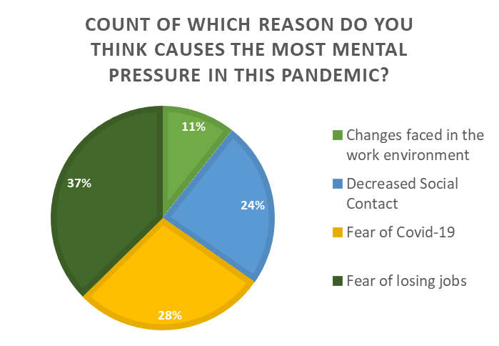

1. Which reason do you think causes more psychological problems among “students” in this pandemic?

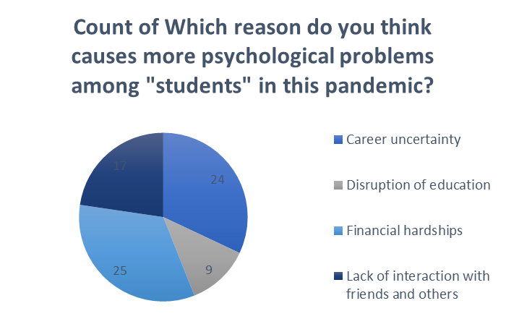

1. Which situation can condense the way of committing suicide in between teenagers during this pandemic?

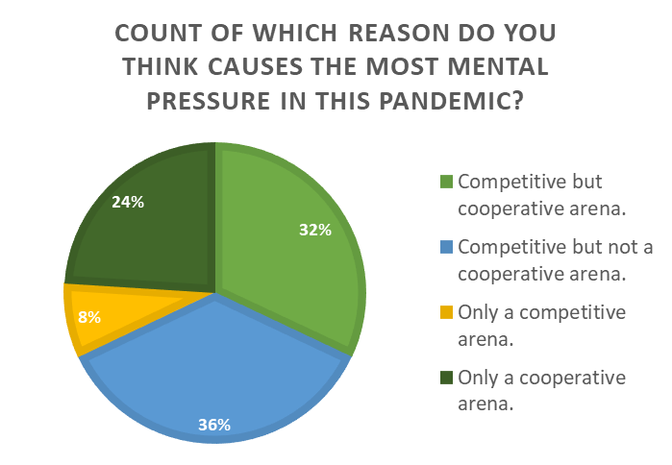

From our surveys, we see that economic problems, financial hardships, fear of losing jobs, and competitive but not a cooperative arena are the perceived main reasons behind mental pressure.

In the next 4 questions, we gave the participants a limited rating scale survey of Strongly Disagree to Strongly Agree with a definite comment in every question to see how they react.

1. I think “Suicidal tendency at present is increasing because people are not actively trying to adapt to the new normal.”

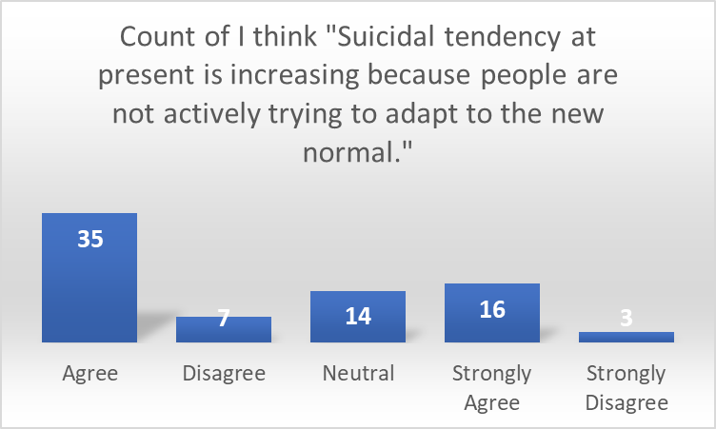

1. I think “People commit suicide, mostly because they are unexpectedly losing their loved ones or their whole family due to covid-19.”

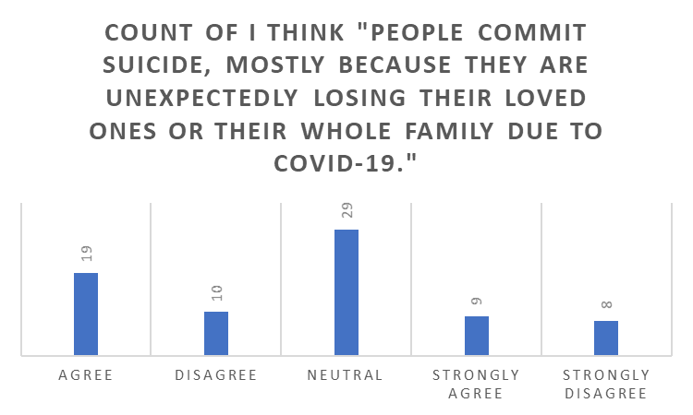

1. I think “the Covid-19 pandemic gives rise to become suicidal more to the people who have pre-existing mental health problems.”

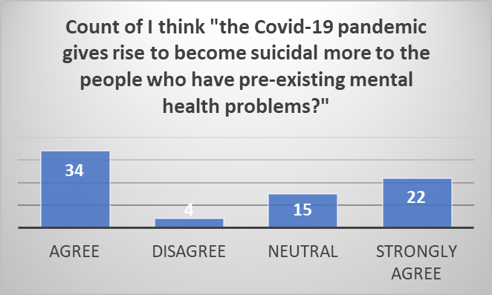

1. I think “social isolation can create suicidal thoughts.”

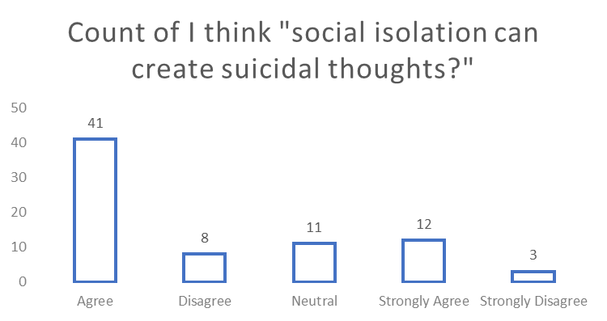

1. I think “If we stop believing in face-to-face communication rather than making online friends, only then suicide rates will be lower than usual?”

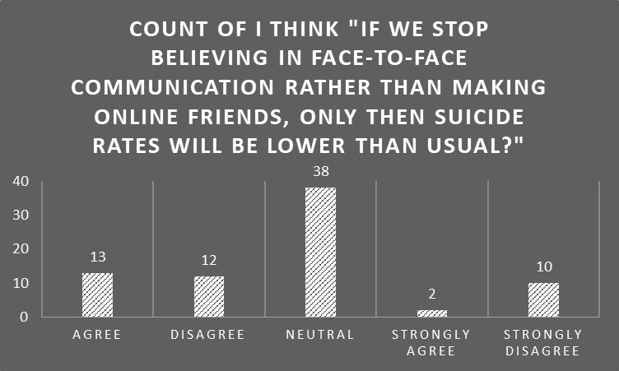

From the surveys we can see that not adapting to the changed environment, existing health problems, social isolation are potential stimulants to having suicidal thoughts. However, losing people is not thought to be a core reason behind it. Even after everything being virtual, people are still not affirmative on shifting fully towards making relationships or connections online.

Next up, we see what they think on whether we, the general people are actually paying the required attention towards the issue of suicides and mental health after the recent outbreak of mortality rate, pandemic and suicides.

1. Are people able to acknowledge the issue of suicide after its recent outbreak in the pandemic?

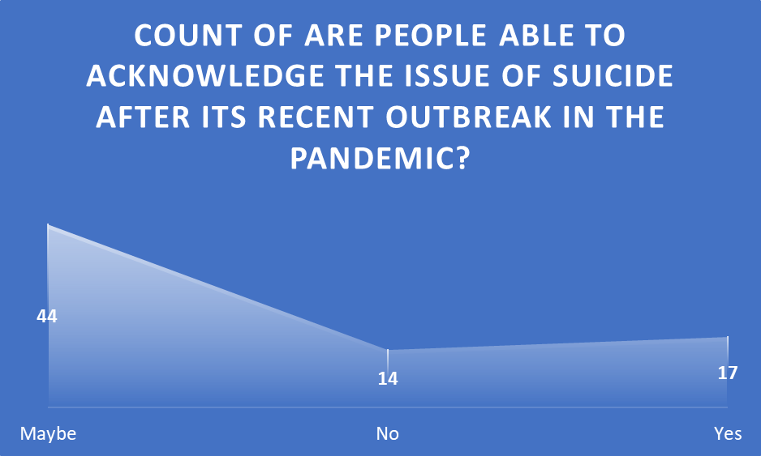

Most participants voted for “Maybe” which indicates that they are not sure if actually the recognition of mental health problem has occurred.

1. Who do you think can help a person from having suicidal thoughts in this pandemic?

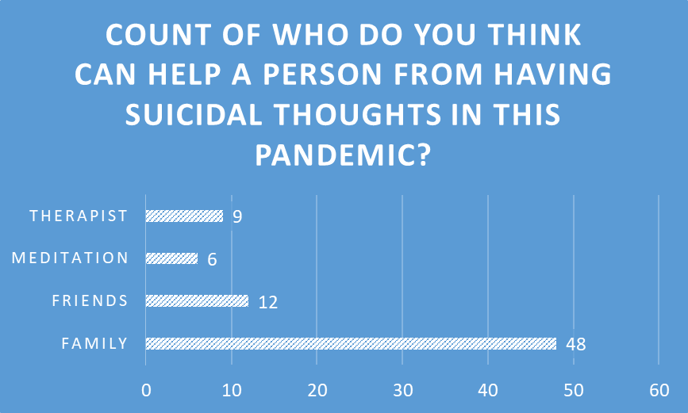

The last question was to help us formulate a recommendation for the problem, as we asked who can actually help the suicidal people. As expected, majority said the parents are in the best position to help.

# Conclusion

With the research we have found some pretty interesting data. From the secondary research, the literature review, we found that the corona virus, and all the associated changes with it might increase the suicidal tendency to a whopping 145%! Our primary research, comprised of 10 interviews and 75 surveys helped us understand why the people have such mentalities and what are eating them away.

After analyzing the data, apparently, our 1st and 2nd hypothesis have been proven true, while the 3rd hypothesis did not stand to be quite true. That is, people think that the main reason behind mental pressure and suicidal thought is economical reasons. They also think that the changes in the new way of the operations of the world are a motivator or a pressure point for having suicidal thoughts. However, sadly, still people feel that the people in general are not actually paying the needed attention to the mental health problem or suicidal tendency.

We have also found that parents have the most ability to influence anyone in moving away from such negative thoughts, and so we recommend creating a healthy relationship between the parents and children. Merely the presence of parents helps stabilize the mental condition. It’s high-time we educate the nation about establishing a friendly relationship between parents and children.

# References

John, A., Pirkis, J., Gunnell, D., Appleby, L., & Morrissey, J. (2020). Trends in suicide during the covid-19 pandemic. BMJ, m4352. doi: 10.1136/bmj.m4352

Bhuiyan, A., Sakib, N., Pakpour, A., Griffiths, M., & Mamun, M. (2020). COVID-19-Related Suicides in Bangladesh Due to Lockdown and Economic Factors: Case Study Evidence from Media Reports. International Journal Of Mental Health And Addiction. doi: 10.1007/s11469-020-00307-y

Are you thinking about suicide or do you know someone who is?. (2021). Retrieved 5 January 2021, from https://www.mayoclinic.org/diseases-conditions/coronavirus/in-depth/covid-19-suicide-risk/art-20490350

Social alienation triggers suicidal tendencies among adolescents. (2021). Retrieved 5 January 2021, from https://www.unicef.org/bangladesh/en/stories/social-alienation-triggers-suicidal-tendencies-among-adolescents

American Psychological Association. (n.d.). *Suicide*. APA. https://www.apa.org/topics/suicide#:~:text=Suicide%20is%20the%20act%20of,depression%20or%20other%20mental%20illness.

Psychology Today. (n.d.). *Suicide Risk Factors and Signs*. Psychology Today. https://www.psychologytoday.com/intl/basics/suicide

*The COVID-19 pandemic and serious psychological consequences in Bangladesh: A population-based nationwide study*. (2021, January 15). ScienceDirect. https://www.sciencedirect.com/science/article/pii/S0165032720328809?fbclid=IwAR0KlrAR7bsFDzsFkgpLCb4cMSOEqzO5qBKhl5df5hXCzPpDywL352obAto

# Appendix

SOC101.22

Sample Questionnaire

*Topic: Perspective on the reasons why suicide cases are increasing in this pandemic situation so much.*

**Survey Questions:**

1. Which reason do you think causes the most mental pressure in this pandemic?

a. Fear of Covid-19

b. Fear of losing jobs

c. Decreased social contact

d. Changes faced in the work environment

2. Do you think "Suicidal tendency at present is increasing because people are not actively trying to adapt to the new normal"?

a. Strongly agree

b. Agree

c. Neutral

d. Disagree

e. Strongly Disagree

3. Do you think people commit suicide, mostly because they are unexpectedly losing their loved ones or their whole family due to Covid-19?

1. Strongly Agree 2. Agree 3. Neutral 4. Strongly disagree 5. Disagree

4. Do you think the Covid-19 pandemic gives rise to become suicidal more to the people who have preexisting mental health problems?

1. Agree 2. Strongly agree 3. Neutral 4. Strongly disagree 5. Disagree

5. Which reason do you think causes more psychological problems among "students" in this pandemic?

1. Disruption of education

2. Career uncertainty

3. Financial hardships

4. Lack of interaction with friends and others

6. Do you think that social isolation can create suicidal thoughts?

1. Agree

2. Strongly agree

3. Neutral

4. Strongly disagree

5. Disagree

7. Are people able to acknowledge the issue of suicide after the recent outbreak of this pandemic?

1. Yes 2. No 3. Neutral 4. Strong yes

8. Who do you think can help a person from having suicidal thoughts in this pandemic?

1. Family 2. Friends

3. Meditation 4. Therapist

9. Which situation can condense the way of committing suicide in between teenagers during this pandemic?

1) Competitive but cooperative arena.

2) Only a competitive arena.

3) Only a cooperative arena.

4) Competitive but not a cooperative arena.

10. If we stop believing in face-to-face communication rather than making online friends, only then suicide rates will be lower than usual?

1) yes

2) no

3) neutral

4) Strongly agree.

**Interview Questions:**

1. Which specific reason do you think impacts people to have increased mental pressure in the pandemic?
2. Do you think economic disaster is one of the main reasons for increasing suicidal tendencies among the people during this pandemic? And Why do you think so?
3. What do you think about having an abusive family? Could it be the cause of someone's suicide?
4. What is your take on social distancing? Are we missing the opportunity to share our stressors and therefore are being more burdened with it?
5. What do you think we can do to avoid the increase in suicidal thoughts?

## Interviews

Nafis

Nafis sent January 2 at 6:33 PM

1. The uncertainty regarding future and the imminence of threat caused by corona. People are in an uncharacteristic zone of discomfort regarding as to future events as already many exams, projects have already been cancelled. And no one can guarantee one's life is safe from corona

Nafis

Nafis sent January 2 at 6:33 PM

2. I believe economic disasters plays an obvious role. Because if people find no secure livelihood or earning source, he can't provide himself or family. Even he Won't be able to support his family with medical costs. So a psychological impact of utmost inferiority develops due to this and may lead to suicidal attempts

Nafis

Nafis sent January 2 at 6:33 PM

3.An Abusive family is among the most severe of curses. Family is all about unconditional love and solidarity. An abusive family makes one feel despicable about himself and he is devoid of basic human affection from the strongest origin which creates immense complexities in the mind. Yes, an abusive family can lead to suicide

Nafis

Nafis sent January 2 at 6:34 PM

4.Social Distancing has put a limitation on our spontaneous human expressions. There is no alternative to live or face to face communication. So such desolation and over dependence on virtual world, makes our thoughts disorganized and increases the burden

Nafis sent January 2 at 6:34 PM

5. We can enagage ourselves with skill developing which requires our constructive attention. We may also simply practice stuff at home, read books or do anything positive which we are passionate about

Nafis

Nafis sent January 2 at 6:35 PM

1. This pandemic is affecting our mental street level in various ways. One of the common reasons is that we are always maintaining a bit more distance with people than usual time. Less interaction with our closed ones makes us more stressful.

2. Many people have lost their jobs in recent times. They are not being able to support their families with required financial assistance. Which leads many of them to commit suicide.

3. Sometimes parents behave roughly toward their children, sometimes other family members are also not being kind to each other, which increases depression and anxiety, this might lead someone to suicide also.

4. Social distancing is a must now a days even though we don't like it all the times, we all should maintain a healthy distance for our own good.

5. We can do more indoor activities that we like, for example gardening, painting, indoor games etc to keep ourselves happy. Also we can connect with people through online which will make us feel better.

Nafis

Nafis sent January 2 at 6:35 PM

ekane shbai shobar interview diye dao

Tanha Tasnim

Tanha Tasnim sent January 2 at 6:36 PM

Person A:

1. I think there are many reasons which impacts people to have increased mental pressure. Such as:

* contamination fears

* isolation distress

*socio-economic concerns

2. Yes I do. Economic disasters create unemployment, debt and many socio-economic problems. Living in a demoralized state of society, victims of such crisis are exposed to risks for developing depression, anxiety or commit suicide. Which results in increasing suicidal tendencies.

3. Of course. Having an abusive family hugely affects a child negatively. According to multiple research report, children who suffer physical and emotional abuse or neglect are at least two to three times more likely to attempt suicide in later life.

4. Social distancing is a necessity right now because of the ongoing pandemic. But its also true that isolation can prevent one from sharing their stressors which could help a person to reduce their burden.

5. To avoid the increase in suicidal thoughts we should do the followings:

* Talking to friends or family about it

* Staying positive and hopeful

* Staying off drugs and alcohol

* Seek counselling, Use suicide Hotline if necessary

* Follow proper medication

Person B:

1.In this pandemic situation people didn’t know where the society is moving. I think not knowing how to re-engage with the world in this new way is leading people to have increased mental pressure .Drastic changes of people’s life have a great impact on their mental health. Because we do not like such huge changes in our life. So, this leads us to frustration, depression and so on.

2.Yes, I think economic disaster is one of the main reasons because all the time we are thinking about job losses career uncertainty and financial hardships. We are continuously worrying about this financial crisis and it’s impossible for us to not worry about it. And this badly effects our mental health and increases suicidal tendencies among us.

3.Definitely an abusive family can increase suicidal tendencies. In this lockdown period we all have to spend 24 hours at home with our family members. And a child of an abusive family have to spend the whole time with them. So, they become victim of more abusive behaviour of their family which creates mental pressure and it can be the cause of their suicide.

4.Social distancing is mandatory in this situation. But it creates more stress because it closes the opportunity of sharing our stressors which increase more burden.

5.We can stay more active to our every day works and try new creative works during this period. And we can spend more time with our parents and siblings. It can freshen up our mind and prevent us from having suicidal thoughts.

You sent January 2 at 6:39 PM

1. Fear of being cut off from job impacts people to have increased mental pressure in the pandemic.

2. Yes, I think economic disaster is one of the main reasons for increasing suicidal tendencies among the people during this pandemic. Because the fear of losing their respective jobs, being homeless and not being able to feed their family members really make them upset.

3. Having an abusive family is a curse unless someone is self reliant. So if the person is dependent on his abusive family, it could be the cause of his suicide.

4. To be honest, social distancing is very hurtful for me. Because I'm the person who feel at home by sharing my sorrows with friends but because of this distancing thing I can't do it. So obviously I'm feeling more burdened with it.

5. To avoid the increase in suicidal thoughts, we have to be supportive towards them. And listening is the first step to being supportive. We have to listen and advise them accordingly.

You sent January 2 at 6:40 PM

1) Plenty of free time and isolation from friends and family is the root cause of increased mental pressure.

2) The economic disaster has played a role in building mental pressure and suicidal tendencies among alot of people. As many people tend to be very afraid of loosing their social status and also felt very uncertain about their future during the the pandemic , it brought along suicidal tendencies in many.

3) Having an abusive family can be one of the main reasons of suicide especially during the pandemic as people had to spend alot more time at home. When families tend to break the confidence and create reasons to cause mental instability among individuals it can become a cause of suicide.

4) Social distancing is a necessary part of fighting this panedemic . A lot of people like to share their feelings and stress with their friends and peers which in terms helps them to deal with it. As social distancing is barrier to that activity it is causing us to be more burdened with the stress. Social distancing is also keeping us in isolation and giving us alot of free time to unnecessarily overthink our problems further adding to the problem.

5) mental support from friends and family and channelling the isolation into productive activities and most importantly keeping oneself entertained can be a way to avoid those thoughts

Jannatul

Jannatul sent January 2 at 7:26 PM

1. I think financial worries. It adversely impact people to have mental pressure in the pandemic.

2. Economic disaster is one of the main reason. Specially to the people who are breadwinners of their family. They feel devastated after losing their job. These mental pressure triggers suicidal tendencies.

3. For some, their home may not be the safe place, especially for those who have experienced domestic violence. So staying home with family most of the day has become more of a suffering in this pandemic for them. Most of the time they have to go from mental stress, and it can cause someone to commit suicide.

4. Social distancing is essential in this covid situation. But it triggers loneliness and people are losing their cool. They can't share their feelings. They feel burdened.

5. We can't connect physically with people because of coronavirus. But their is internet. We can connect virtually. We should talk with our friends via internet

Person-2

1. I think the main specific reason that have increased mental pressure in the pandemic has been the lack of communication between friends and relatives . A source of venting of our emotions gets blocked due to not having the interaction and it increases mental pressure .

2. Yea, I think so since we as human being are able to operate well with our economical based lifestyle and when it is hampered , it causes great stress and hampers our everyday life which makes us helpless .

3. I think having an abusive family is a curse by itself. Knowing you have to deal with all the abuse from your family can often lead to mental breakdowns which results in people wanting to commit suicide.

4. I think social distancing is very hard for us as we all love to interact with each other without certain boundaries. But at a time like this , there is nothing we can do but be patient and maintain distance. Yea , we are definitely missing the opportunity to share our stress and other problems as nothing really beats speaking your mind while being face to face. As a result the lack of interaction due to social distancing is burdenining us with many unreleased stress.

5. I think firstly , we should look into our family and create a great environment between our families as we have to spend almost all the time staying at home in this situation. We should be open with our parents and they also should be patient with our ways of thinking and increase communication. Families can be the key to avoiding the increase by just being there with the affected person and sometimes that is enough to take their mind out of such thoughts.

Ashik

Ashik sent January 2 at 8:07 PM

1. Anxiety levels were highest among an estimated 8.6 million people whose income fell and that’s way this income issue in this pandemic affects us certainly.

2. Economic disaster is obviously is of the main reason for a person to fall down mentally in this situation as the job amounts is getting less and being fired out from their daily lives job that put a burden on their head and for some people that leaves people to suicidal thoughts.

3. Protecting children from violence during the COVID-19 pandemic requires all sectors to undertake Coordinated measures. Abusive family can be factor for anyone’s reason for suicide as in this situation everyone needs family support.

4. The impact of the COVID-19 pandemic is drastically changing the lives of people, including the lives of young people because of this social distance. But because of this isolation we can prevent people from getting affected by this deadly virus.

5. To avoid suicidal thoughts we should more indulge with our family member, we should do activities in our family to keep everyone happy and make sure that they are not feeling burden in this hard time. Making the more use of online platforms to keep ourselves busy and make the best of our time.

person 2.

1. The reason why this pandemic is hitting more on us is because we can not contact our friends and all the family members face to face and that was we feel stressed out all the time apart from the virus.

2. People are losing jobs and not being able to contact their family members always and that leads many people to suicidal thoughts.

3. In this pandemic what we need is cooperative family member to calm us down and an abusive family can lead us to suicidal thoughts because we are already worrying about us and our family not to get affected by this virus so being abusive and putting us on pressure can give us suicidal thoughts.

4. Social distancing is really so important for anyone to avoid this virus. This social distancing might bring a tough time for our friends and family but it helps a lot for everyone end of the day. According to many countries this self-time can be beneficial or bring bad thoughts to people it’s basically up to every people how they want to spent their isolation time.

5. If we spent more time with our family then we will always be entertained in that way. In that way we can share ideas about a lot of stuff and keep ourselves busy in this pandemic. A lot of creative works can be done in this pandemic because we are getting a lot of free time.